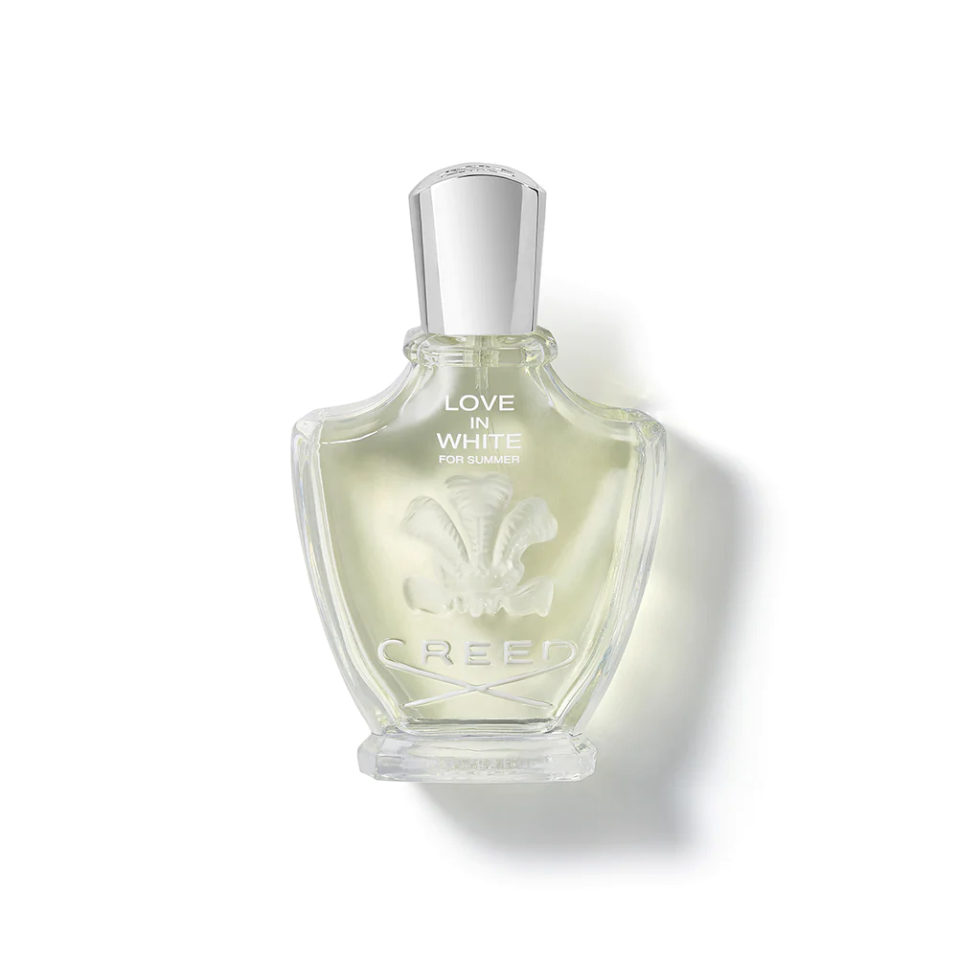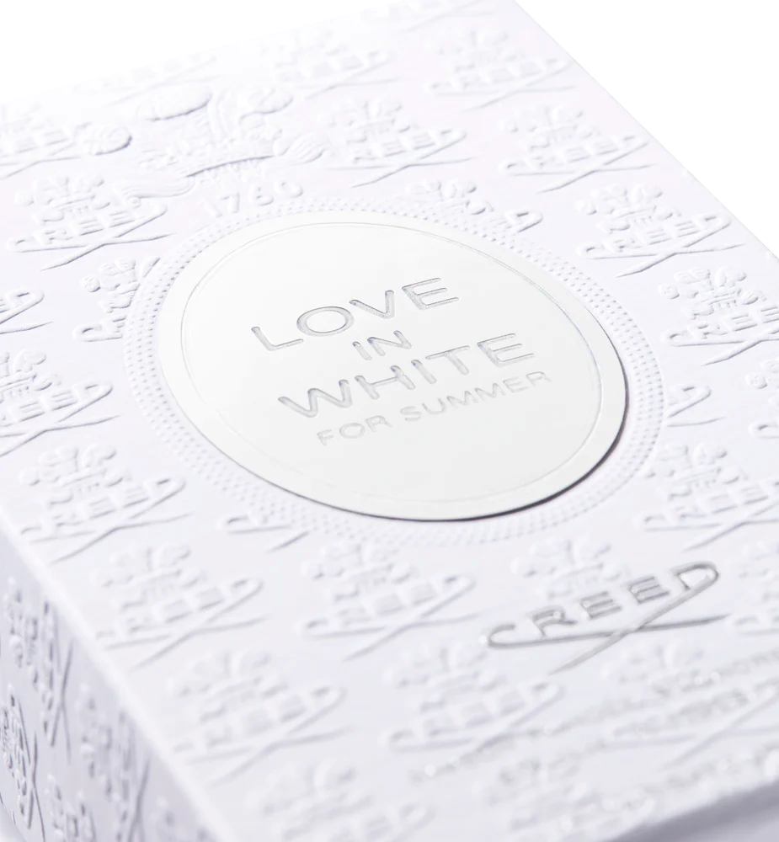

**CREED LOVE IN WHITE FOR SUMMER**

$400.00

Tax Included.

Spray 100 mL

IN STOCK

### Product Details

Taking inspiration from The House of Creed’s best-selling women’s fragrance Love In White, Love In White For Summer is a dreamy fresh floral that bottles white-hot nights on the Côte d'Azur and the quest for eternal summer.

This scent transports wearers to the French Rivera where chic white accessories, crisp waves and long holiday escapes reign.